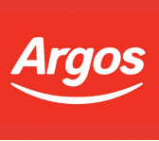

Argos - Trading Support Manager

Full Time
Job description
Argos Camberley are currently looking to hire a Trading Support Manager.
-Full time 38.75 hours a week.
-£18 500 to £24 000 per annum.
-Must have management experience.
Apply on line at https://argos.careers/find-a-job/2678
Job details
location
42-46 Obelisk Way, Camberley, Surrey, GU15 3SG
contact no
0345 165 7112
Deadline: Mon 28 October

