LEAVES:

Due to the time of year that it is, please be mindful that there is going to be a lot of leaves falling from trees. Please remember grounds maintenance are not responsible for clearing leaves from enclosed gardens (front or rear) and also they are not responsible for anything within fenced off flower beds. This is yours as an occupant to maintain.

FLY TIPPING- If you see people fly tipping – please report it. There is an issue within Alamein road currently with people dumping rubbish under trees. Report them if you see them.

**POLITE NOTICES:**

1. **For residents of Alma Gardens, Lock Road and also within Salamanca estate – please discontinue parking on grassed areas.**
2. **Please do not use the grit bins as general waste bins especially as now that winter is only round the corner.**
3. **Residents who have received letters regarding rubbish. Please remove it or it will be removed for you and a charge will follow.**
4. **Street lighting is a particular issue at the moment. As you can appreciate Amey staff do have to go home and generally, when they do, the street lights aren’t on so we rely heavily on occupants to report street lighting issues. To do this please take the serial number from the lamppost and report to the helpdesk.**
5. **If you have a caravan please ensure it is being kept in accordance with your licensing agreement- particularly in Humphrey and Quetta park.**

**Wow, it’s the end of October already. This year is flying by. Halloween partys, trick or treating and fireworks are at the ready. Our local team here have been inundated with jobs, we have PWRR moving to Aldershot and we managed to have a chat and a brew with the wives to give them a taster of whats to come.**

**For Recognition for their hard work, Alison Flaherty (Amey), Claire Beatley (Amey) and Dave Simpson (DIO) had been Kindly invited along to the ‘Beating the Retreat’ at ATC Pirbright by Colonal Stafford, Commanding Officer – I think we can all agree you all look lovely- Well Done!!!**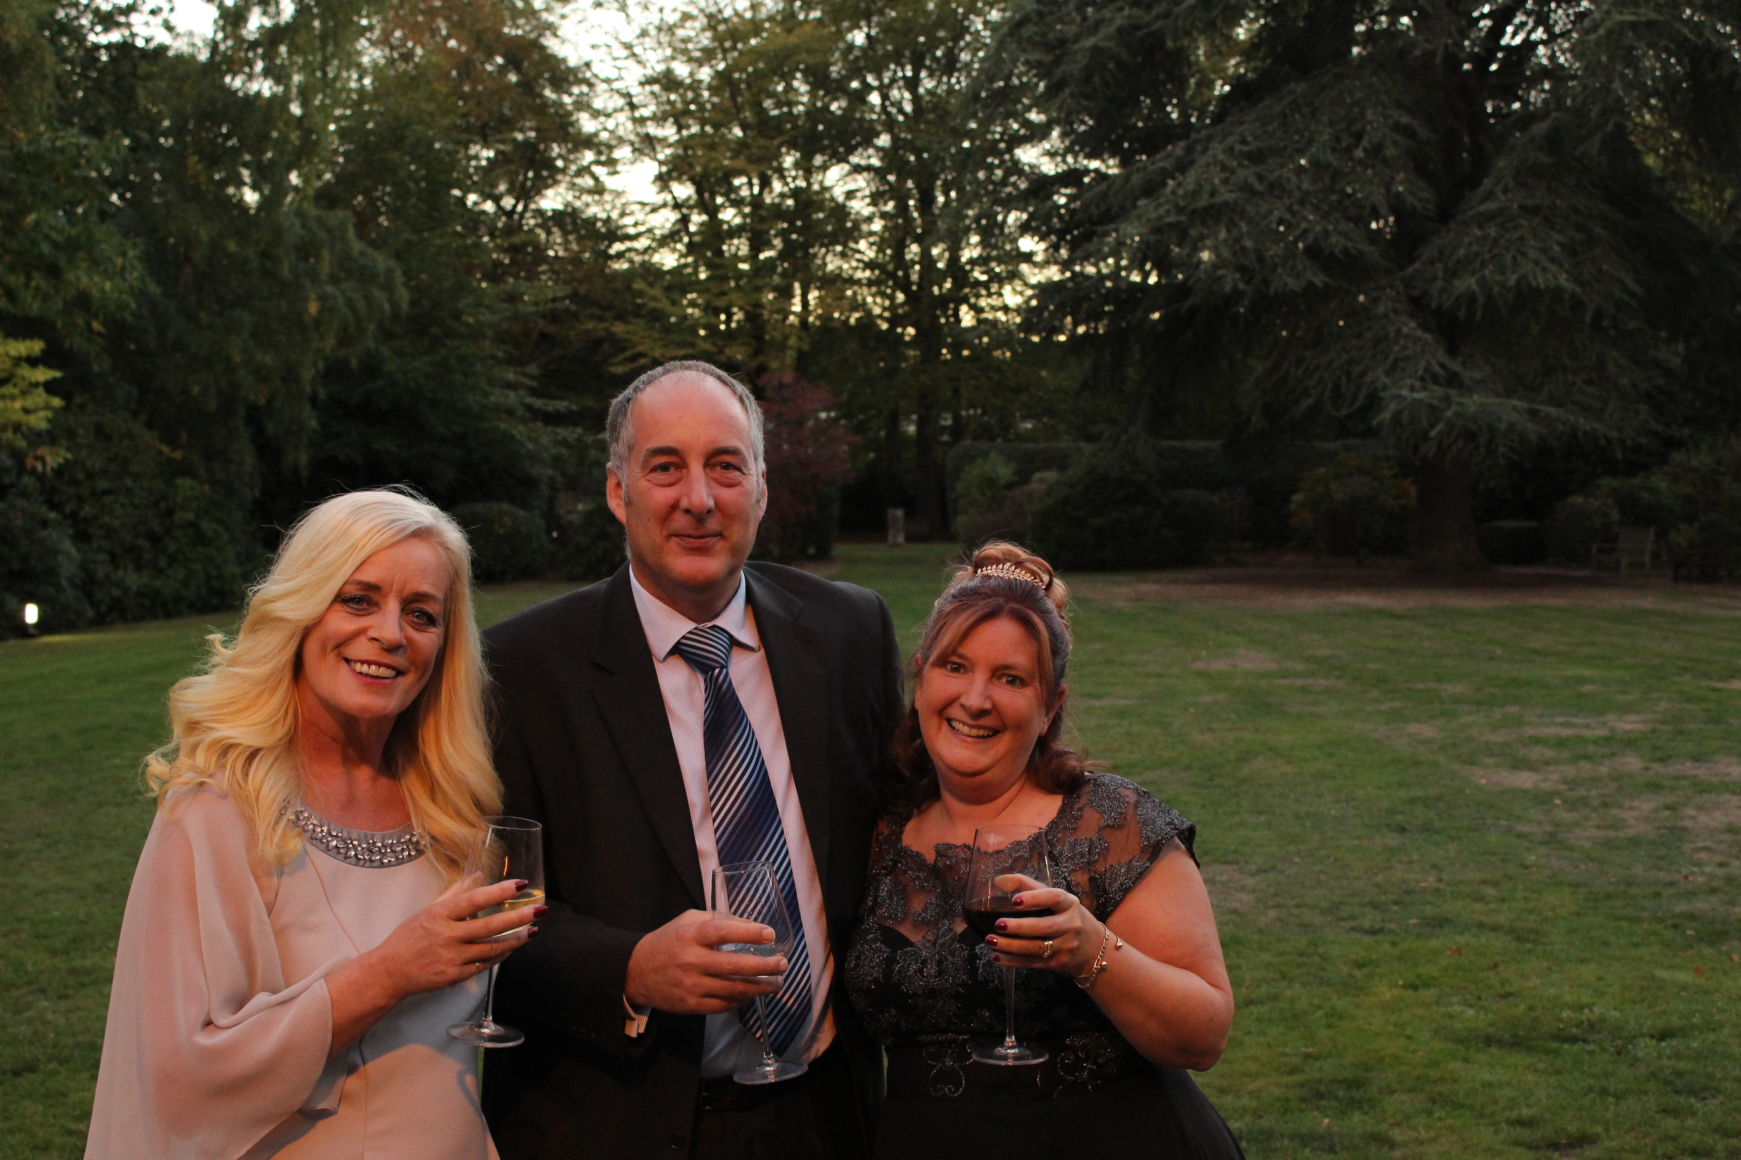

We like to keep in contact with you, so if you have any issues or queries and are not able to come and see me we also have an abundance of ways to contact us please see the link below:

https://www.ameydefenceservices.co.uk/housing/contact-us/

LOCAL CUSTOMER SERVICE CENTRE ADVISOR - ALDERSHOT

Issue 5| Oct 2018