WELCOME TO BRUNEI STABLES
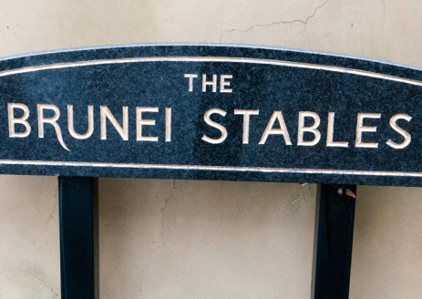
Welcome to Brunei Stables. Whether you are a complete beginner, intermediate or advanced rider, there are lessons available for all at Brunei Stables. This page provides you with information on lessons for you and your family as well as timings, membership and lesson costs. This page also provides information on the RDA group ran here at Sandhurst, and a brief history about the stables and various unique traditions.
Brunei Stables were a gift from his Majesty, The Sultan of Brunei following the Sovereigns Parade held on the 8th August 1989, and in his honour, the RMAS Stables was named after him. For more information on the history and traditions of Brunei Stables, such as the role of the CoH and the Academy Adjutants horse that walks up the steps of Old College on a Sovereigns Parade please click here.
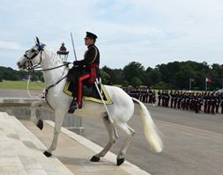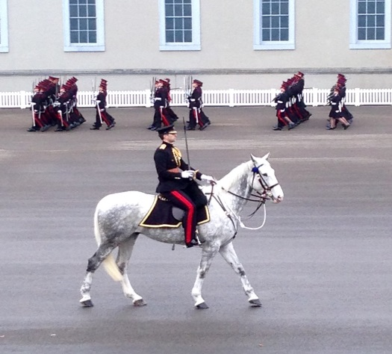
Ceremonial Duties
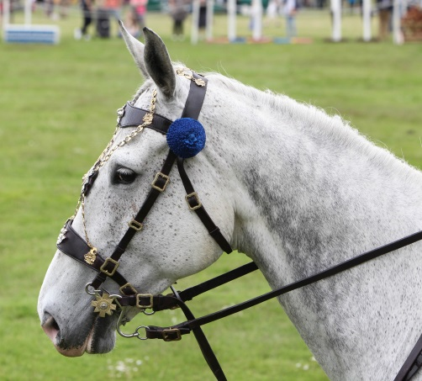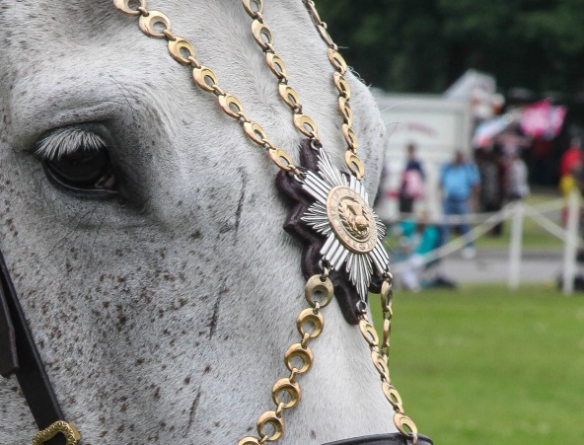
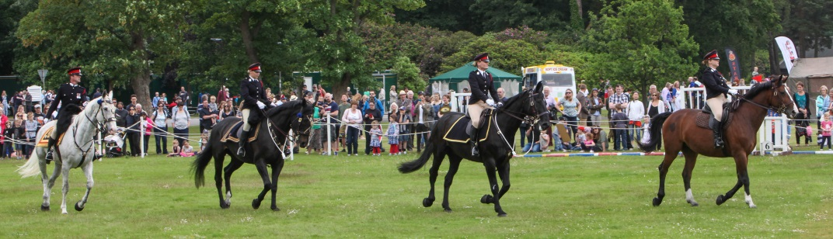
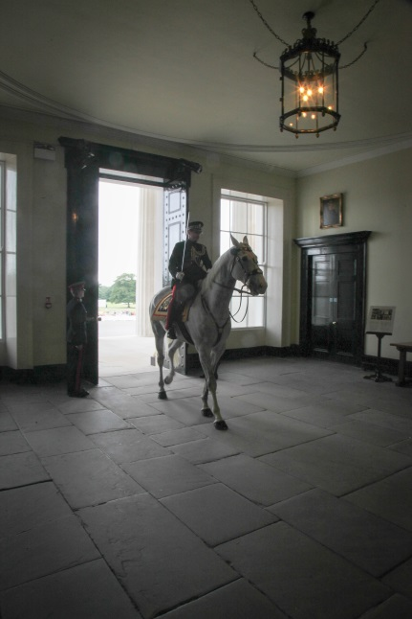
SADDLE CLUB
A number of riding lessons are held at Brunei Stables and all abilities are catered for. For the Trotting Tots you must be aged 4 and above, Junior Saddle Club 5 and above and Saddle Club over 16. To take advantage of this excellent facility you must contact Coral Webb, Stables Administrator on 01276 412386 or coral.webb115@mod.gov.uk

You are encouraged to have two lessons before joining the club. After two lessons, if you are happy and wish to continue riding, you are required to complete a short membership form and pay annual membership subs of £30.00.

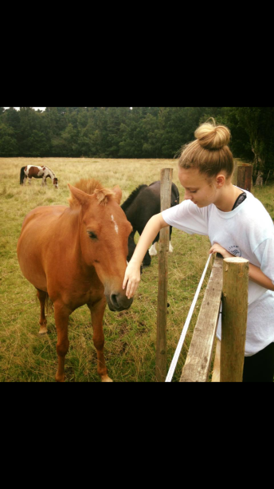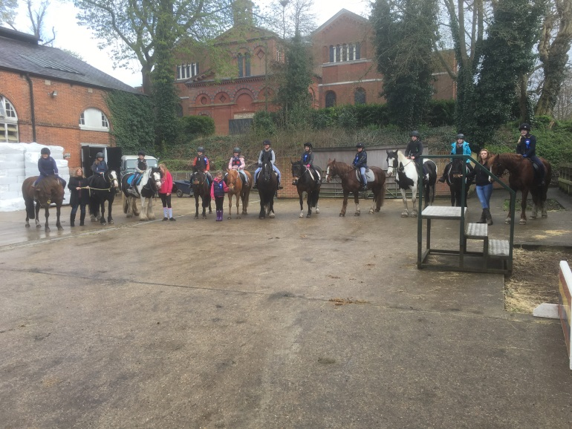
Well- deserved rest time A handful of the ponies and riders in Junior Saddle Club
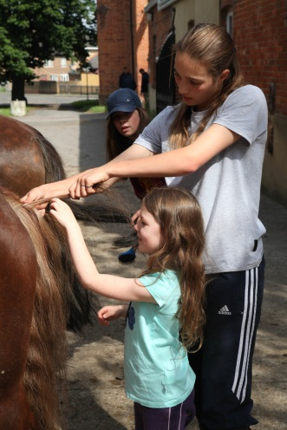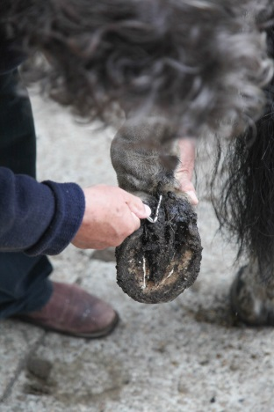
Not just all riding…. Clean Feet please

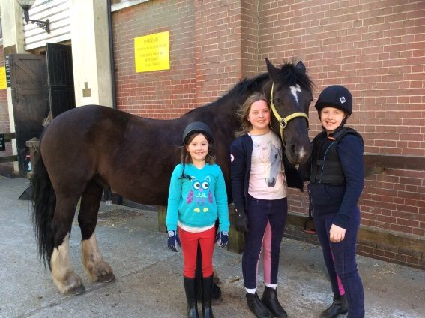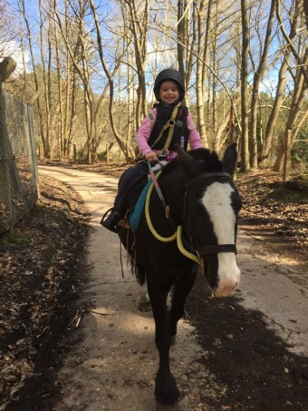
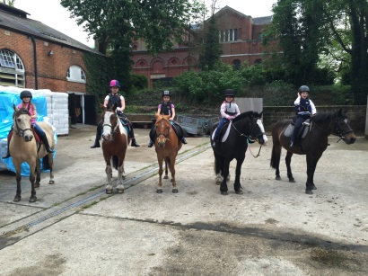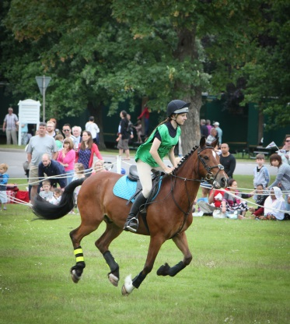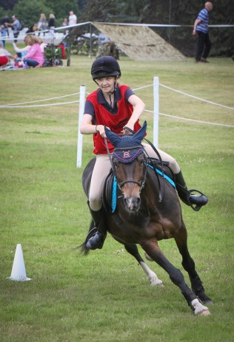
Ready & raring to go… Emma & Noggin taking it Ellie & Caro want to win
in their stride

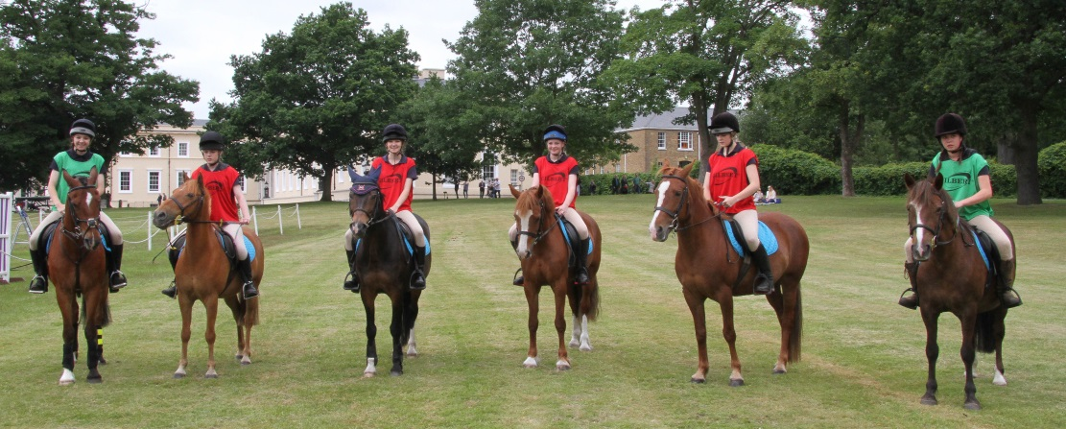
Getting ready for their Junior Saddle Club Lesson – games today…..
JUNIOR SADDLE CLUB
This is aimed at children aged between 5 and 16. Classes are suitable for beginners, novice, intermediate and advanced. The lessons are for one hour which does include getting on and off your pony. The days and times, as well as costings are listed below
DAY OF WEEK | TIME | ABILITY | INSTRUCTOR | MILITARY PRICE | CIVILIAN PRICE
Monday | 1615-1730 | Novice | Mandy | £21.00 | £26.00
Monday | 1730-1830 | Advanced | Mandy | £21.00 | £26.00
Tuesday | 1615-1715 | Novice/Intermediate | Mandy | £21.00 | £26.00
Tuesday | 1730-1830 | Intermediate/Advanced | Mandy | £21.00 | £26.00
Wednesday | 1615-1730 | Advanced/Intermediate | Pippa | £21.00 | £26.00
Wednesday | 1730-1830 | Beginner | Pippa | £21.00 | £26.00
Thursday | 1615-1715 | Novice | Mandy | £21.00 | £26.00
Thursday | 1730-1830 | Novice/Intermediate | Mandy | £21.00 | £26.00
Friday | 1615-1715 | Intermediate | Pippa | £21.00 | £26.00
Friday | 1730-1830 | Intermediate/Advanced | Pippa | £21.00 | £26.00
Saturday | 1000-1100 | Beginner | Claire | £21.00 | £26.00
Saturday | 1100-1200 | Novice | Claire | £21.00 | £26.00
Sunday | 1000-1100 | Beginner/Novice | Pippa | £21.00 | £26.00
Sunday | 1100-1200 | Intermediate/Advanced | Pippa | £21.00 | £26.00

Jumping Lesson Listening to his Instructor Lovely Lulu
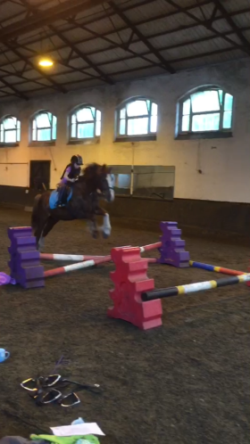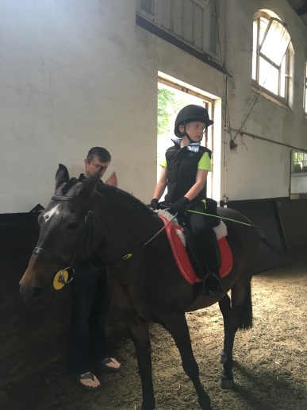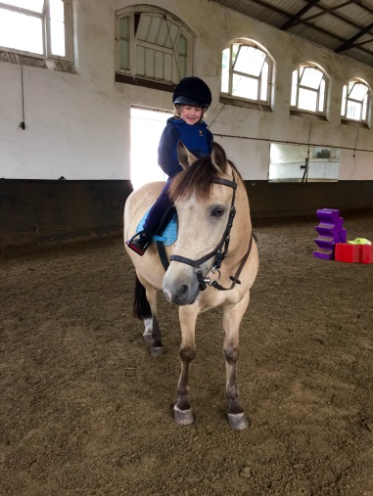
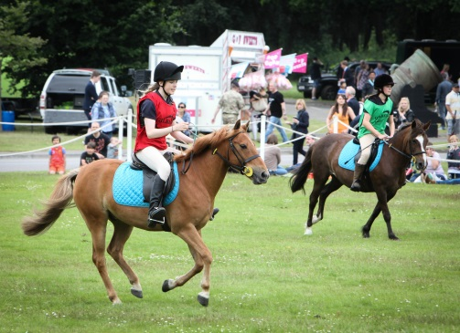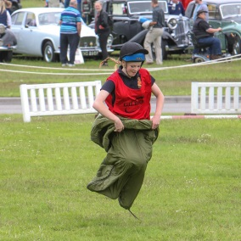
. Not just about riding in a school Where’s your horse?

SADDLE CLUB
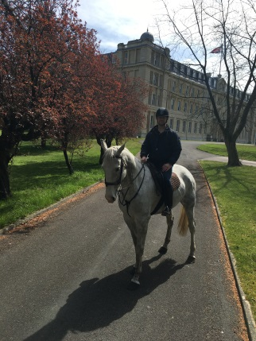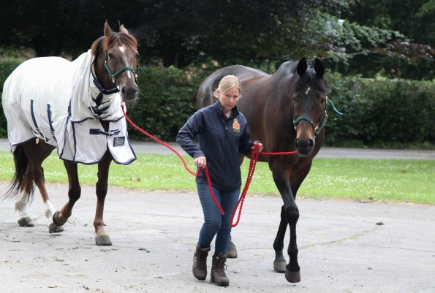
These lessons are aimed at anyone over the age of 16. We offer classes suitable for beginners, novice, intermediate and advanced. Days, times and costs are listed below
DAY OF WEEK | TIME | ABILITY | INSTRUCTOR | SERVING MILITARY PERSONNEL | MILITARY DEPENDENT PRICE | CIVILIAN PRICE
Monday | 1830-1930 | Advanced | Mandy | £16.00 | £21.00 | £26.00
Monday | 1930-2030 | Advanced | Mandy | £16.00 | £21.00 | £26.00
Tuesday | 1830-1930 | Novice | Mandy | £16.00 | £21.00 | £26.00
Tuesday | 1930-2030 | Novice/Intermediate | Mandy | £16.00 | £21.00 | £26.00
Thursday | 1830-1930 | Intermediate | Mandy | £16.00 | £21.00 | £26.00
Thursday | 1930-2030 | Advanced | Mandy | £16.00 | £21.00 | £26.00
Friday | 1830-1930 | Beginner | Mandy | £16.00 | £21.00 | £26.00
Friday | 1930-2030 | Advanced | Mandy | £16.00 | £21.00 | £26.00

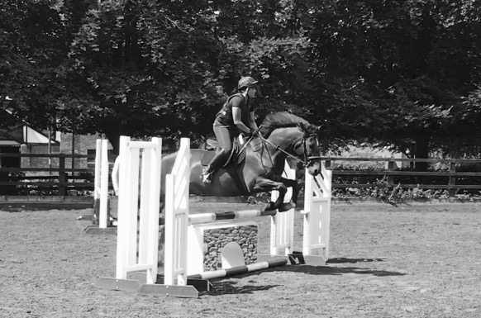

PRIVATE LESSONS
We offer private one to one lessons. These are for one hour at a cost of £40.00.
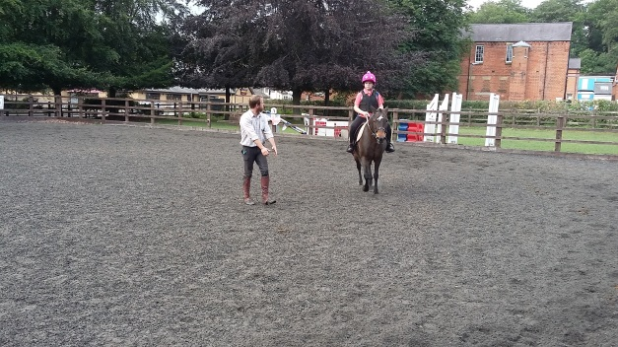

RDA – RIDING FOR THE DISABLED ASSOCIATION
The Sandhurst RDA Group was founded in 1973 and operates from Brunei Stables. The group provide therapeutic riding sessions for children from local schools.
For more information on the Sandhurst RDA please click here. More information on the RDA Organisation and the work they do can be found by clicking here.
HACKS
Any member of Brunei Stables can hack either around the academy or for the more competent rider, out on Barossa. Those wishing to go onto Barossa must always book through Stables Secretary and have an assessment. This is one cost for all, as follows
Hack around the academy £10.00
Hack onto Barossa £20.00 Green route
£30.00 Yellow route
£40.00 Red route
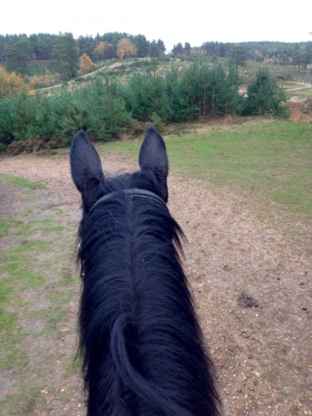
Bird’s Eye View of Barossa…..
BATTLEBACK
Battle back uses Adaptive Adventure Training and Sports Rehabilitation to help seriously wounded Service personnel gain independence and confidence to focus on what they can achieve rather than what they cannot. More information on Battle Back can be found on the Help for Heroes website.
ARMY PENTATHLON
The core function of Brunei Stables is to offer education and instruction to Officer Cadets and help coach them in Army Pentathlon.
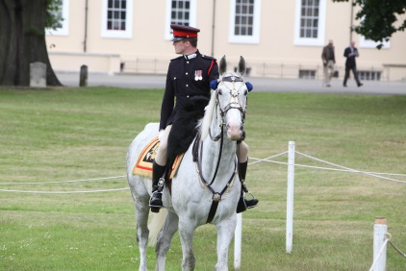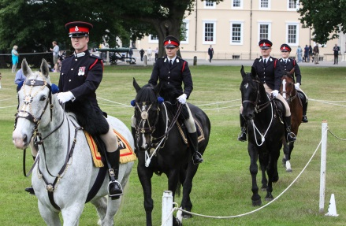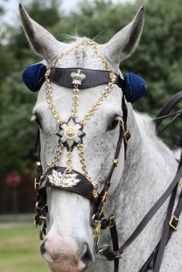
MORE INFORMATION
As well as the riding club, hacks, military training and the RDA group meetings, Brunei Stables also put on a number of events throughout the year, e.g. clear rounds, gymkhana, drag hunting. Please contact the Stables Secretary for more information.
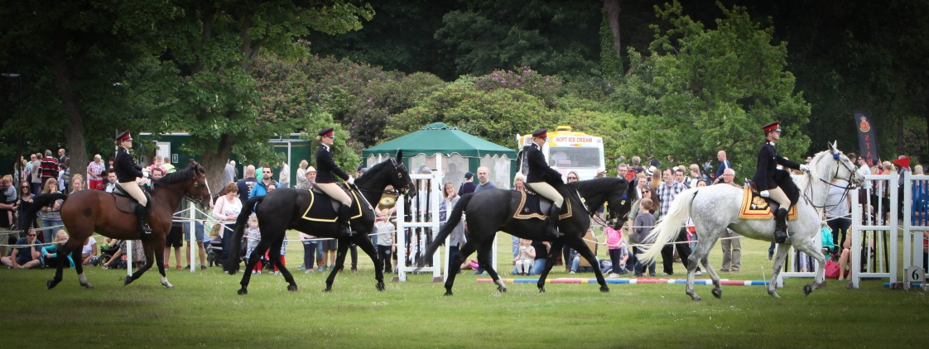
Please note that the membership fees and costs of all lessons and attendance at events are subject to change and can be done so without notice. Private lessons are delivered around the CoH’s core responsibilities and may not always be available at your chosen time. During the summer months, some of our horses are returned back to the Household Cavalry so that they can undertake their ceremonial duties. All lessons, hacks, events and other activities organised or run from Brunei Stables is subject to the health, wellbeing and safety of all of our horses, therefore any activity can be cancelled, suspended or deleted at any time and without prior notice. No compensation will be given when cancellations occur due to the health, wellbeing and safety of our horses.

Contact Details
Brunei Stables Secretary Coral Webb
Military Telephone Number 94261 2386
Civilian Line 01276 412386
Email coral.webb115@mod.gov.uk

