NEW CLOTHING BANKS IN SUPPORT OF COMBAT STRESS

PLEASE HELP US TO SUPPORT COMBAT STRESS BY DONATING CLEAN & DRY REUSEABLE, WEARABLE, NEW OR PREVIOUSLY WORN ITEMS: (In bags please).

- PAIRED: MENS, LADIES, CHILDRENS SHOES; BOOTS, TRAINERS; FOOTBALL BOOTS.
- LADIES, MENS, CHILDRENS CLOTHING.
- BELTS, HANDBAGS, HATS.
LOCATIONS: Stables car park opposite Fort Royal and Clarke Crescent Children’s Park

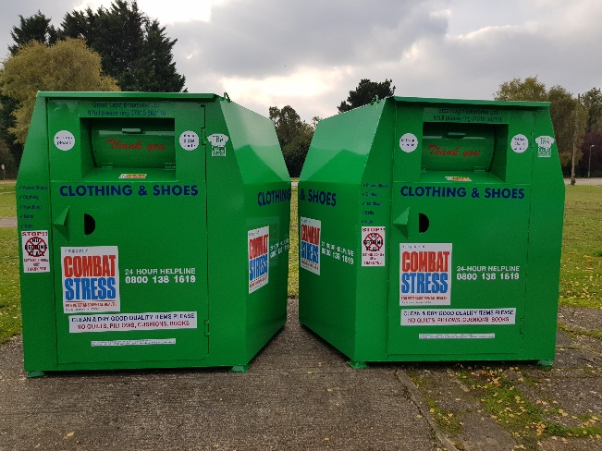

PLEASE DO NOT LEAVE BAGS OUTSIDE THE CLOTHING BANKS. THANK YOU

