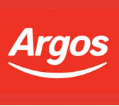

Argos - Customer Advisor

Job summary
Part time
Job description
Argos Camberley are currently looking to employ a Customer Advisor.
- 20-hour contract
- 5 days a week including weekdays and weekends.
- Must be fully flexible.
- £8.50 per hour.
- Under 21 - £7.80 per hour.
Apply on line at: https://argos.careers/find-a-job/2763
Job details
salary
On Application
location
42-46, The Square Camberley, Obelisk Way, Camberley GU15 3SG
apply by
Mon 28 October

